PROJECT DOCUMENTATION
Automated Incident Triage & Routing in ServiceNow
L1 IT Support & SOC Incident Triage Flow built with Workflow Studio

Author | Mohammed Zia Ur Rahman
Platform | ServiceNow Personal Developer Instance (Workflow Studio, no-code flow)
Flow name | L1 IT Support & SOC Incident Triage
Target table | Incident [incident]
Validation test run | 27 October 2026 (incident INC0010003)
Document date | October 2026

1. Introduction
IT Service Management (ITSM) teams receive a continuous stream of incident tickets, and every ticket must be read, classified, prioritised and sent to the right team before any real troubleshooting can start. When this triage is done by hand, it is repetitive, inconsistent between analysts and slow, and the delay is most costly when the ticket is actually a security event.
This project builds an automated triage flow in ServiceNow Workflow Studio. The moment an incident is created, the flow reads its Short description, decides whether it describes a security problem or a standard IT problem, assigns the incident to the appropriate team (IT Securities or Service Desk) and sets its priority. The whole flow is configured without custom code.

1.1 Purpose of this document
This document records the design, step-by-step build, testing and findings of the project, supported by screenshots taken during the work. It is intended to let a reader understand what was built, reproduce it on their own developer instance, and see honestly how it performed in testing.

1.2 Scope
- In scope: incident-created trigger, keyword-based classification of the Short description, assignment group and priority updates, test execution and audit of the run.
- Out of scope: email or chat notifications, SLA timers, machine-learning classification and production hardening. These are listed as future enhancements in Section 9.

2. Problem Statement and Objectives

2.1 Problem statement
Tier 1 analysts spend a significant share of their time on repetitive categorisation and assignment work. Inconsistent manual routing means security-related tickets can sit in a general queue while standard requests are handled first, which delays Security Operations (SecOps) response and lengthens normal resolution cycles.

2.2 Objectives
- Trigger automatically on every new incident, with no analyst action required.
- Classify each incident as Security or Standard IT using keywords in the Short description.
- Assign security incidents to IT Securities at priority 2 - High.
- Assign all other incidents to Service Desk at priority 3 - Moderate.
- Keep a complete, reviewable execution record of every run for audit and troubleshooting.

3. Technology and Environment
Component | Details
Platform | ServiceNow Personal Developer Instance (PDI), requested from developer.servicenow.com; region selected: Brazil
Automation tool | Workflow Studio (flow builder), flow created in the Global application scope
Trigger | Record trigger: Created, on the Incident [incident] table
Flow logic | Two If conditions (Security, Standard IT) followed by Update Record actions
Test data | Incident INC0010003, caller David Miller, Short description "Unauthorized SSH brute-force security breach"
Browser | Google Chrome
Version control | Git and GitHub

4. Solution Design

4.1 Flow overview
The flow follows a simple evaluate-then-update pattern each time an incident record is created:
- Trigger: an Incident record is created.
- Evaluate Security: if the Short description contains a security keyword, the Security branch applies.
- Update (Security): set Assignment group to IT Securities and Priority to 2 - High.
- Evaluate Standard IT: if the incident is not a security incident, the Standard IT branch applies.
- Update (Standard IT): set Assignment group to Service Desk and Priority to 3 - Moderate.

4.2 Routing rules
Condition | Short description keywords | Assignment group | Priority action
Security | virus, malware, breach, security, unauthorized | IT Securities | 2 - High
Standard IT | Anything that does not match the security keywords | Service Desk | 3 - Moderate
Priority is set directly by the flow. The keyword list above is the intended rule set from the project design; Section 7 discusses how the configured conditions behaved in testing.

5. Implementation Walkthrough

Step 1: Provision the ServiceNow developer instance
A personal developer instance was requested from the ServiceNow Developer site. The setup dialog shows the region selection followed by instance configuration, which provisions the database, plugins and settings. Once the status reached Ready to use, the instance became available for building the flow.
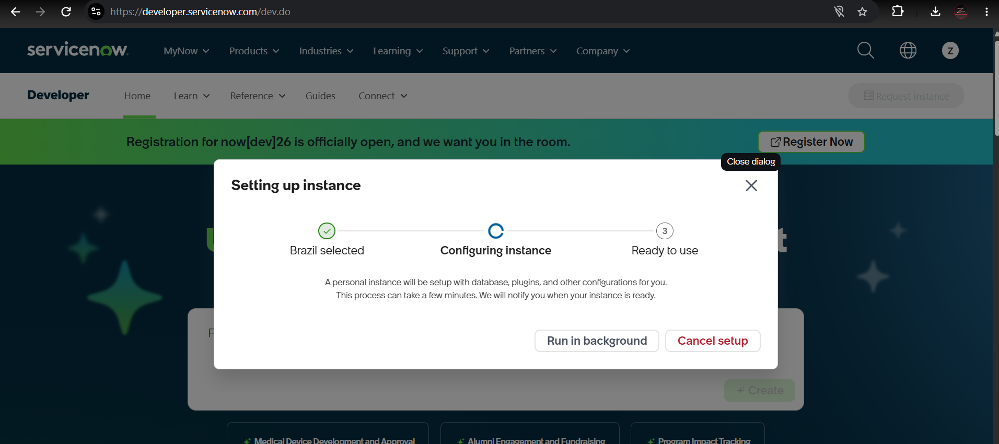
Figure 1: Developer instance being provisioned on developer.servicenow.com.

Step 2: Create the flow in Workflow Studio
In Workflow Studio a new flow was created with the name L1 IT Support & SOC Incident Triage, the application scope set to Global, and a description recording its purpose: automatically routing incoming incidents to Service Desk or SOC based on keywords and setting priority.
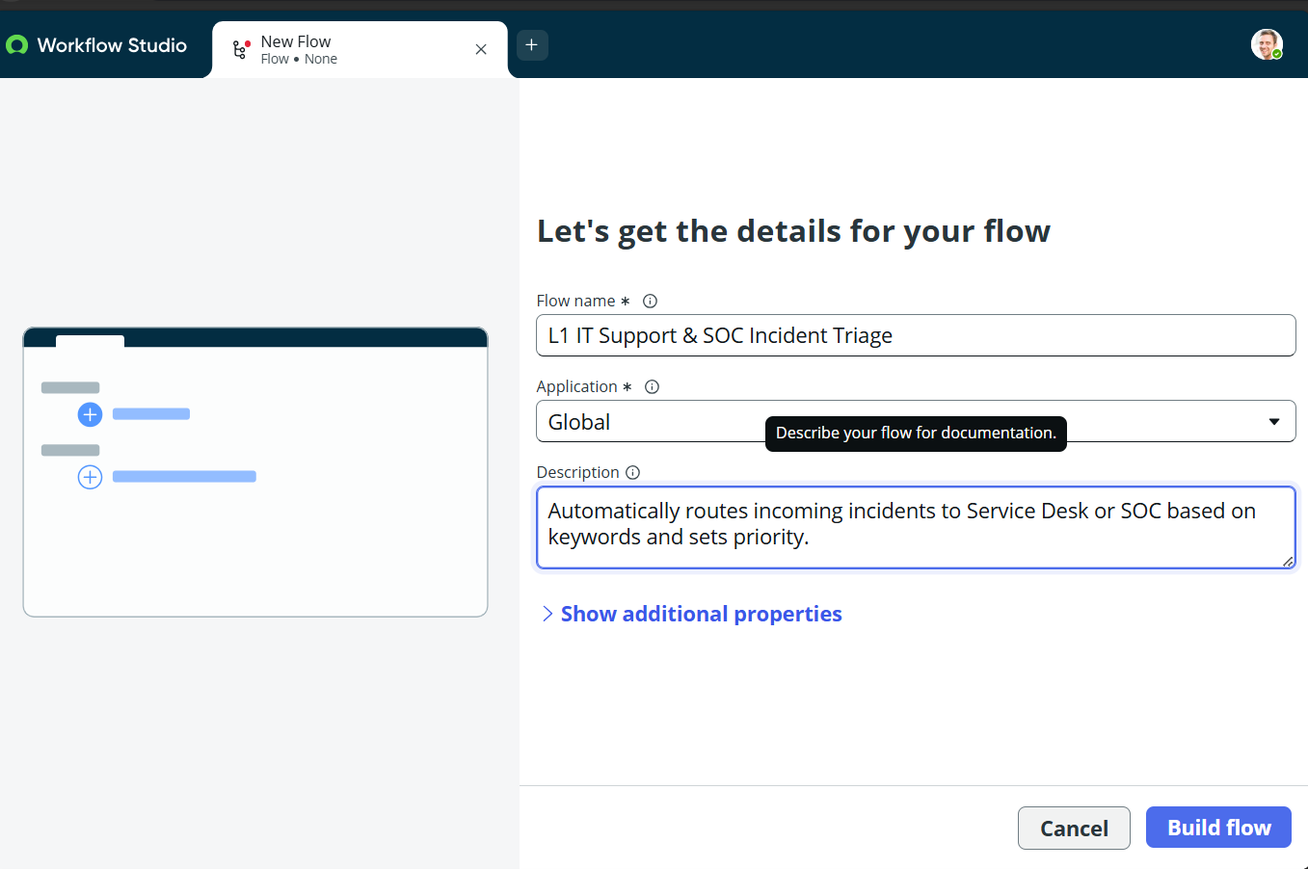
Figure 2: New flow details: name, application scope and description.

Step 3: Configure the trigger
The trigger type Record was chosen, with the Created option, so the flow runs once for every new record on the Incident table. Created was used rather than Created or Updated to avoid re-routing an incident every time an analyst edits it.
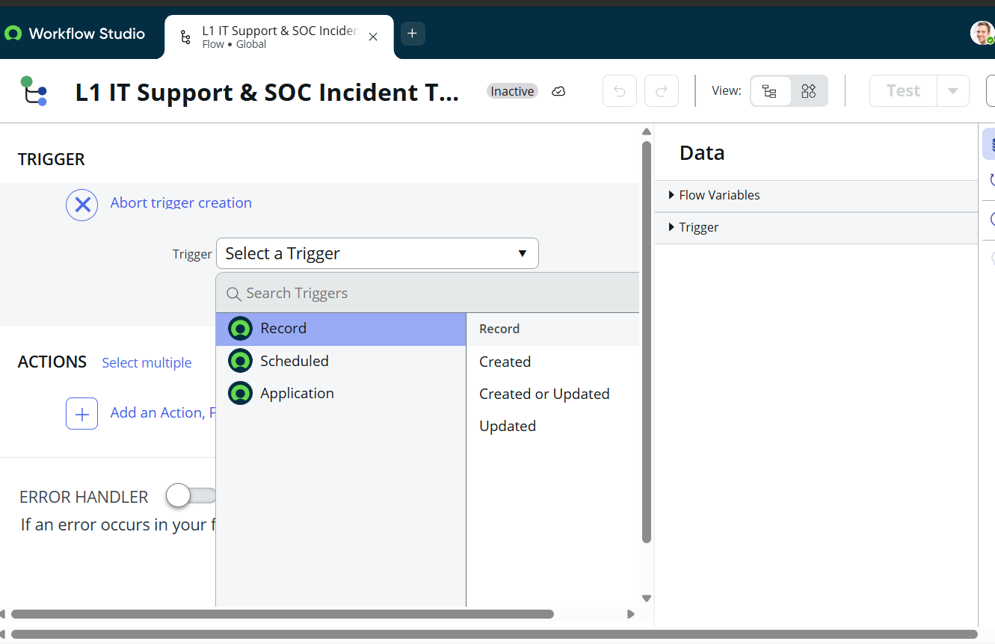
Figure 3: Selecting the Record > Created trigger.

Step 4: Add the conditional routing logic
The first flow-logic block is an If condition. Its condition compares the incident's Short description, taken from the trigger's Incident Record data, against the security keywords. Additional condition sets can be combined with OR so that any single keyword is enough to match.
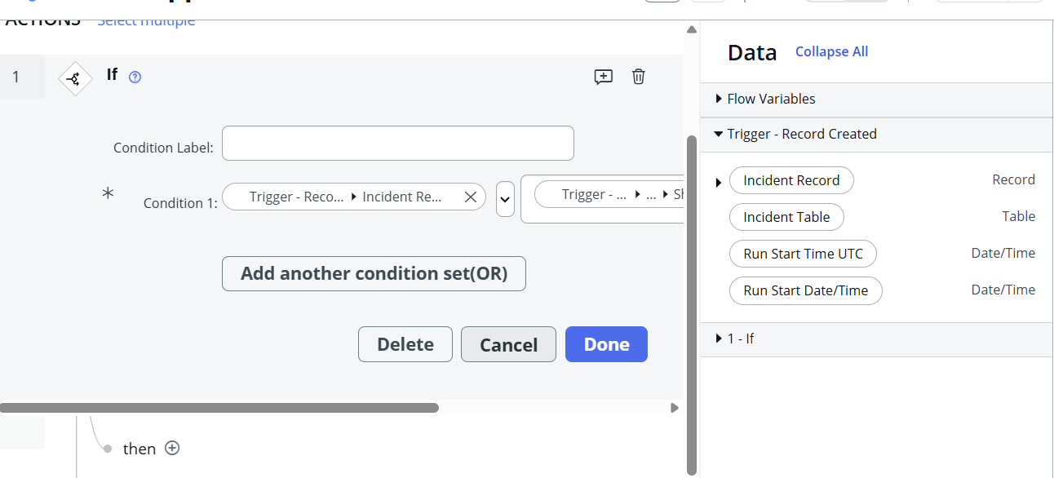
Figure 4: Adding the first If block and its condition.
The condition was given the label Security, making the flow easy to read in the editor and in execution logs.
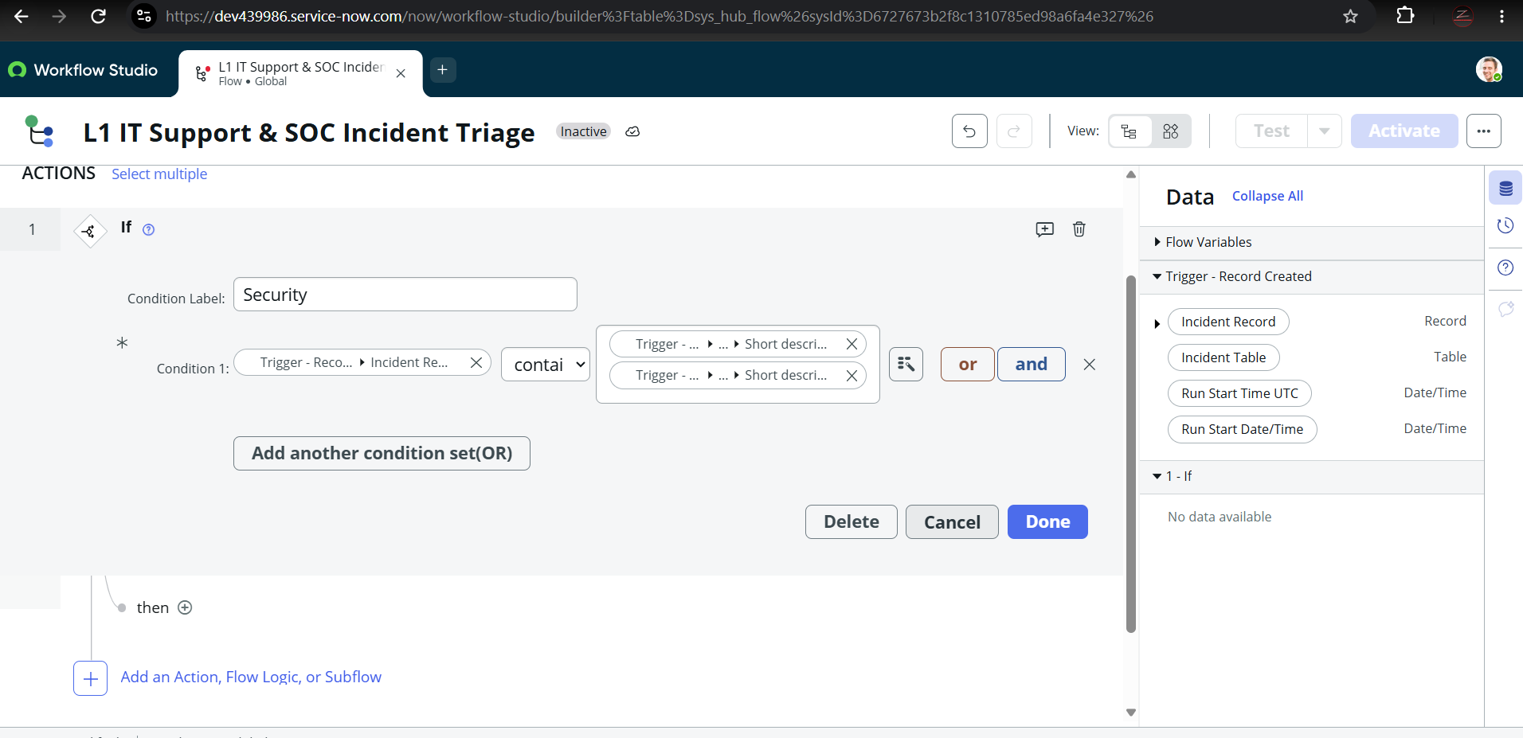
Figure 5: If block labelled "Security" with a Short description "contains" condition.

Step 5: Configure the Security branch action
Under the Security condition, an Update Record action was added against the Incident table. It sets the Assignment group to IT Securities and the Priority to 2 - High, so a suspected security incident reaches the security team immediately and is flagged as high priority.
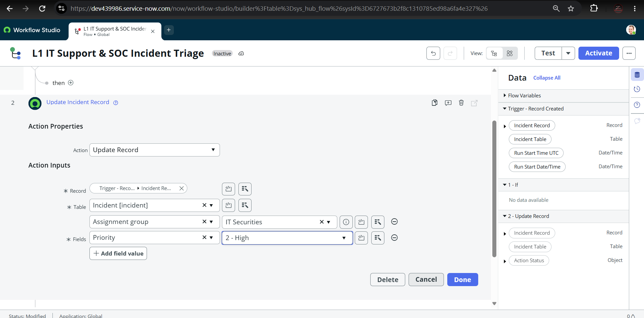
Figure 6: Security branch: Update Record sets Assignment group = IT Securities and Priority = 2 - High.

Step 6: Configure the Standard IT actions
A second If block, labelled Standard IT, handles every other incident. Its Update Record action assigns the incident to Service Desk at priority 3 - Moderate, the default handling for routine requests.
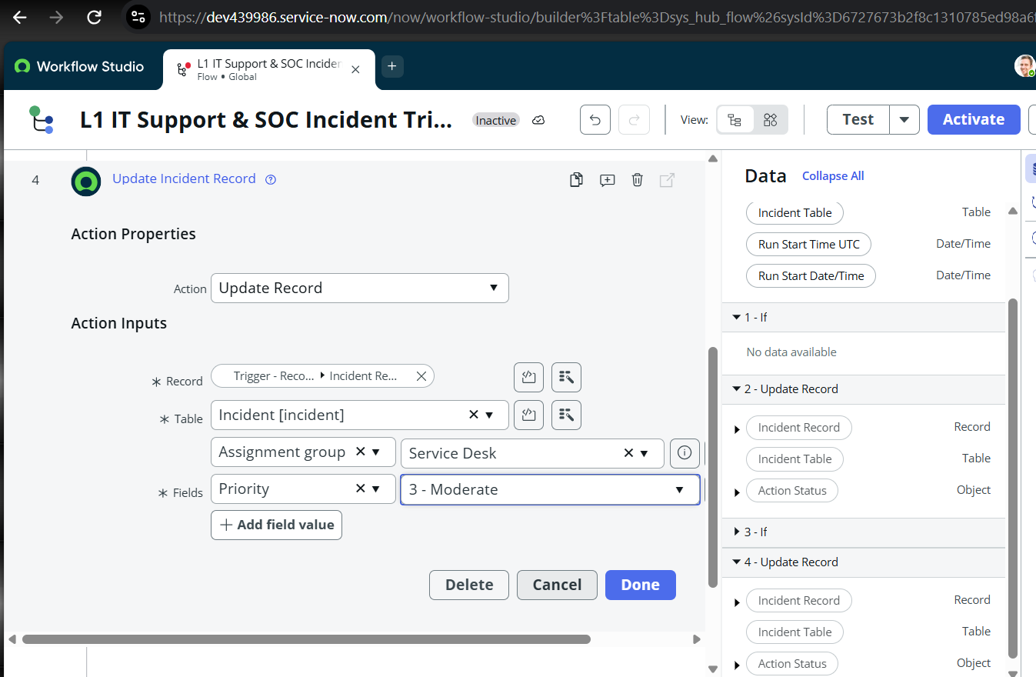
Figure 7: Standard IT branch (action 4): Assignment group = Service Desk, Priority = 3 - Moderate.
A further Update Record action (action 5) was added that takes the record from the output of action 4 and also applies Service Desk and 3 - Moderate.
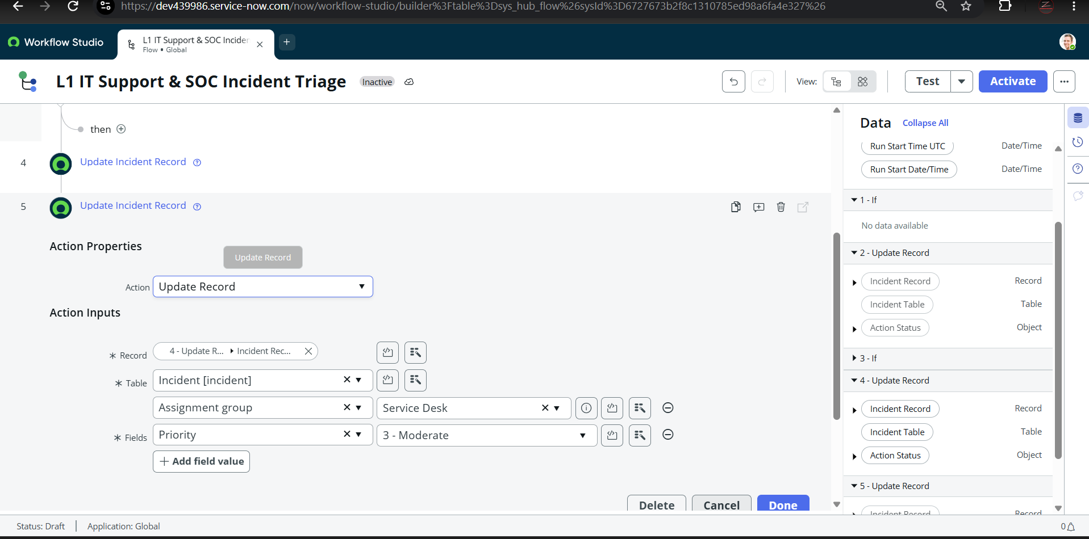
Figure 8: Action 5: Update Record referencing the output of action 4.

Step 7: Review the complete flow
The finished flow has one trigger (Incident Created) and six actions: the Security If (1) with its update (2), the Standard IT If (3) with its update (4), and two further Update Record actions (5 and 6). The overview below shows the structure and the data pills available to each step.
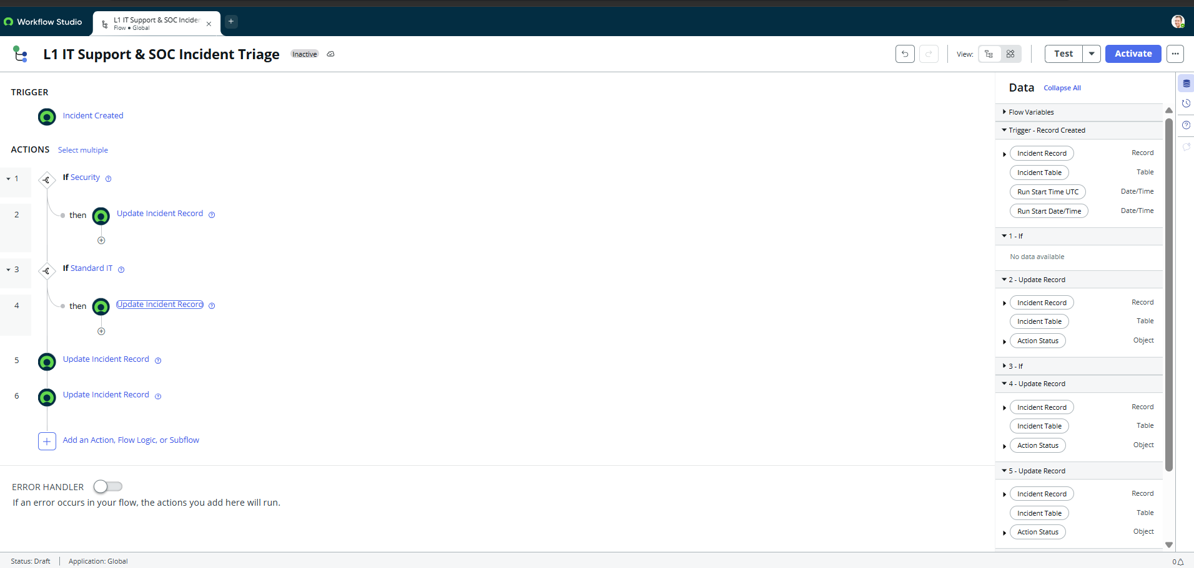
Figure 9: Complete flow: Incident Created trigger, Security and Standard IT conditions and Update Record actions.

6. Testing and Validation

6.1 Creating the test incident
A new incident, INC0010003, was created with the Short description "Unauthorized SSH brute-force security breach", which contains several of the intended security keywords. On creation the form shows default values: Category = Inquiry, Impact = 3 - Low, Urgency = 3 - Low, Priority = 4 - Low, with the Assignment group empty.
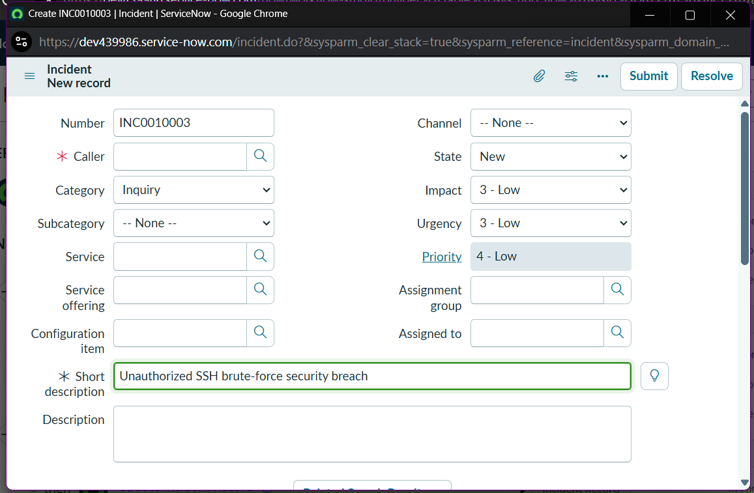
Figure 10: New incident INC0010003 with the security-themed Short description and an empty Assignment group.
Submitting the form without a caller was rejected by the platform with a mandatory-field message. Caller David Miller was then supplied, which satisfies the validation.
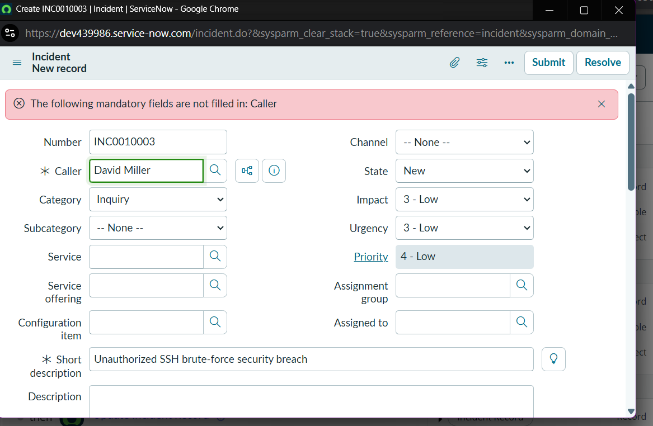
Figure 11: Mandatory-field validation for Caller, then caller added.

6.2 Running the flow test
Using Workflow Studio's Test feature, the flow was run against INC0010003. The dialog confirms the test finished and links to the flow execution details.
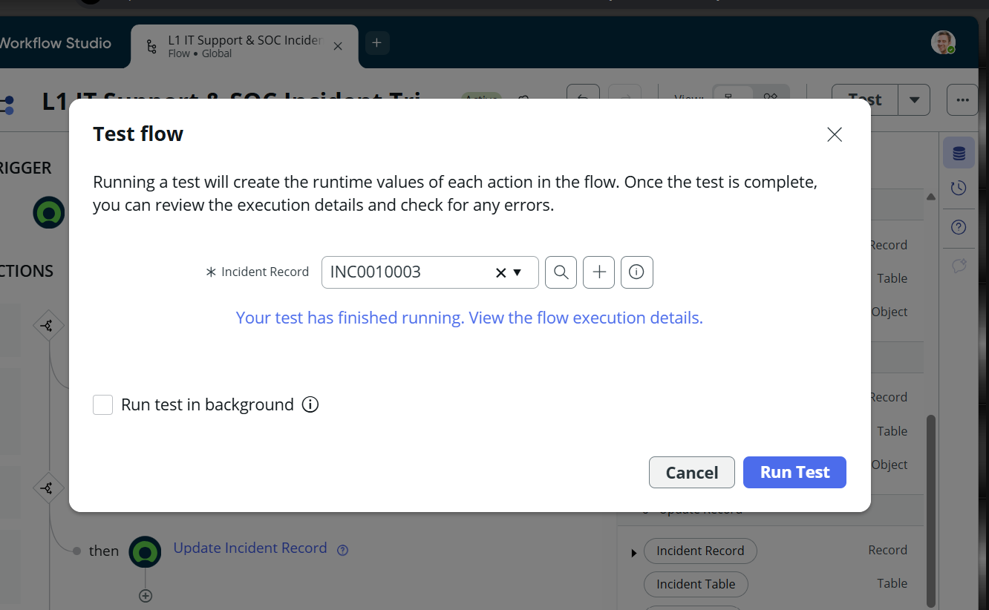
Figure 12: Test flow dialog: test run against INC0010003 completed.

6.3 Execution results
The execution details page lists the run as Test Run - Completed, run as System Administrator on 2026-10-27 at 12:07:14, with a total runtime of 227 ms.
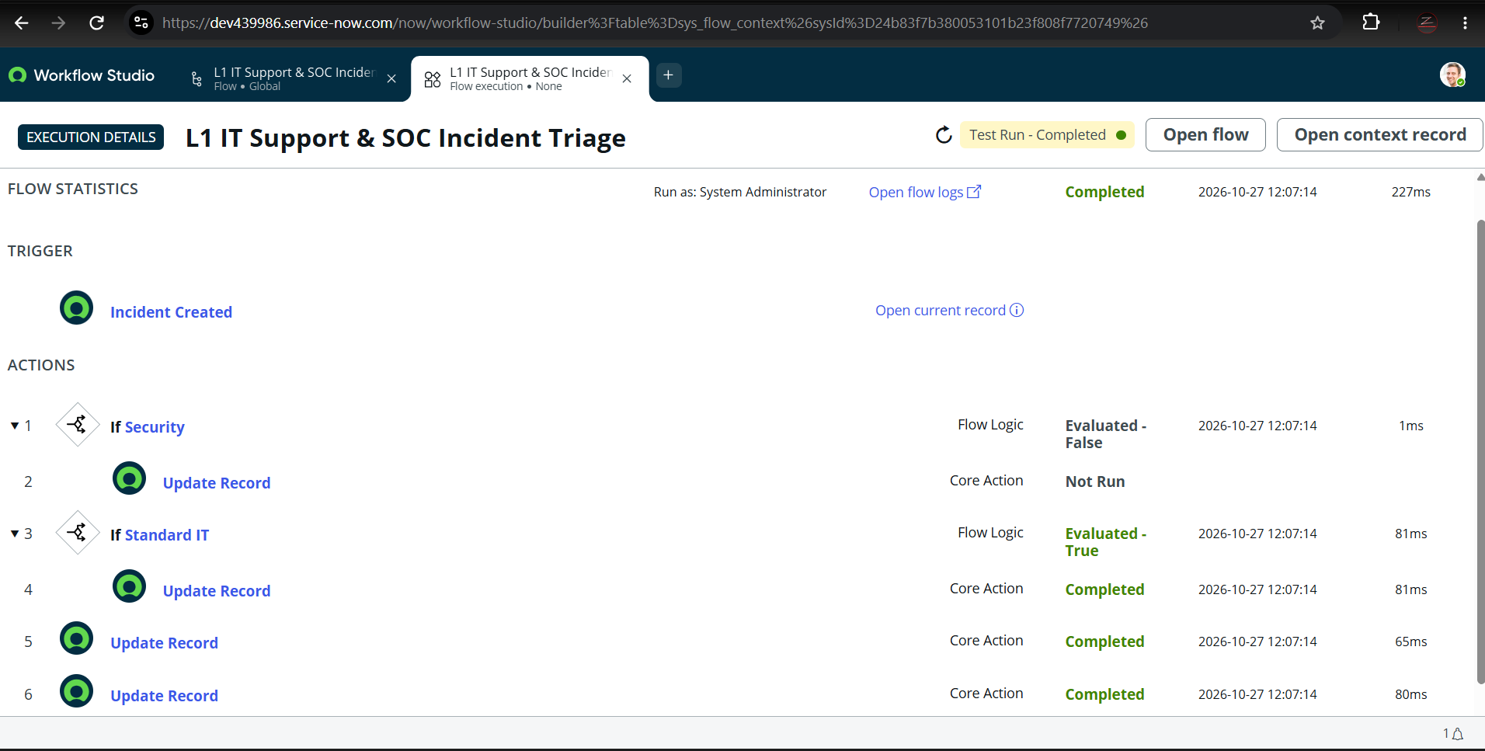
Figure 13: Flow execution details with per-action status and timings.
# | Step | Type | Result | Time
1 | If Security | Flow Logic | Evaluated - False | 1 ms
2 | Update Record (Security branch) | Core Action | Not Run | -
3 | If Standard IT | Flow Logic | Evaluated - True | 81 ms
4 | Update Record (Standard IT branch) | Core Action | Completed | 81 ms
5 | Update Record | Core Action | Completed | 65 ms
6 | Update Record | Core Action | Completed | 80 ms

7. Results, Observations and Recommended Improvements

7.1 What worked
- The flow triggered automatically on incident creation and finished the whole run in 227 ms.
- Every step, including conditions that evaluated to False, appears in the execution record with its result and timing, giving a full audit trail.
- The Standard IT path completed and applied its assignment group and priority actions.

7.2 Observation from the test run
Security branch did not match the test incident
In the execution details (Figure 13) the Security condition evaluated False and the Standard IT branch ran for INC0010003, even though its Short description contains "Unauthorized", "security" and "breach". The intended routing to IT Securities at priority 2 - High was therefore not demonstrated in this run.

Two details visible in the configuration screenshots are likely contributors and are worth checking first:
- Condition values (Figure 5). The values on the right of the "contains" operator appear as data pills that reference the trigger's Short description field, rather than typed keywords such as "security" or "breach". A condition that compares the Short description with itself or with a field reference will not match the keywords.
- Action placement (Figure 9). Actions 5 and 6 sit at the top level of the flow, outside both If blocks, so they would run for every incident and could overwrite the result of the Security branch.

7.3 Recommended corrections
- Edit the Security condition so each keyword (virus, malware, breach, security, unauthorized) is a typed text value, using one OR condition set per keyword.
- Replace the separate Standard IT If block with an Else branch of the Security condition, so exactly one branch can run.
- Move or delete actions 5 and 6 so they only run inside the intended branch.
- Re-run the test with INC0010003 and with a routine incident (for example, "Printer not working") and confirm Security = True for the first and Standard IT for the second.
- Replace Figures 5 to 9 and 13 with screenshots of the corrected flow and its passing test.

7.4 Measured results
Measure | Result | Source
Flow execution time (test run) | 227 ms | Figure 13
Actions in flow | 6 (5 completed or evaluated, 1 not run) | Figure 13
Trigger | Incident Created, fires on every new incident | Figures 3 and 9
Security routing verified | Not yet; pending the corrections in 7.3 | Figure 13
Comparisons such as manual versus automated triage time should be quoted only after a baseline is measured on real or simulated tickets.

8. Benefits and Impact
- Speed: classification and assignment happen at creation time, with no analyst in the loop.
- Consistency: the same rules are applied to every ticket, removing differences between analysts.
- Security focus: once the keyword conditions are corrected, suspected security incidents are escalated to the security team at high priority without waiting in a general queue.
- Auditability: the Flow Execution History records every evaluation and action for review.
- Low maintenance: the logic is configured visually in Workflow Studio and can be changed by an administrator without code.

9. Version Control and Future Enhancements

9.1 Repository setup
Project files and documentation were placed under Git version control and pushed to GitHub using the following commands:
git init
git add .
git commit -m "feat: complete ServiceNow automated incident triage flow"
git branch -M main
git remote add origin https://github.com/Zia2691r/AutoFix-Desk.git
git push -u origin main

9.2 Future enhancements
- Add email or Microsoft Teams notifications to the assigned group when a high-priority incident is created.
- Set Impact and Urgency so priority is calculated by ServiceNow's priority matrix, and set the incident State.
- Extend classification to network, access and hardware categories with their own assignment groups.
- Add SLA targets and escalation if an incident is not acknowledged in time.
- Evaluate Predictive Intelligence or another machine-learning approach to improve classification beyond keywords.
- Log each routing decision to a work note on the incident for easier review by analysts.

10. Conclusion
This project demonstrates how a no-code flow in ServiceNow Workflow Studio can automate the first and most repetitive stage of incident handling. The flow triggers on every new incident, evaluates the Short description, updates assignment group and priority, and records a complete execution trace. The build was documented step by step, from instance provisioning to a completed test run in 227 ms.
The test also showed the value of validating with realistic data: the security-themed incident was routed through the Standard IT branch, which exposed a condition-value issue and an action-placement issue. Both have clear fixes, listed in Section 7.3. With those corrections applied and re-tested, the flow will provide dependable first-line routing that sends security incidents to the right team immediately and keeps routine requests moving through the Service Desk.
The work also provided practical experience with ITSM concepts, incident lifecycle fields, conditional automation and test-driven troubleshooting, all of which carry directly into Service Desk and SOC analyst roles.

Appendix A: List of Figures
Figure | Description | Section
1 | Developer instance being provisioned | 5 - Step 1
2 | New flow details | 5 - Step 2
3 | Record > Created trigger selection | 5 - Step 3
4 | First If block and condition | 5 - Step 4
5 | Security condition (Short description contains) | 5 - Step 4
6 | Security branch Update Record | 5 - Step 5
7 | Standard IT branch Update Record | 5 - Step 6
8 | Action 5 Update Record | 5 - Step 6
9 | Complete flow overview | 5 - Step 7
10 | New incident INC0010003 | 6.1
11 | Mandatory Caller validation | 6.1
12 | Test flow dialog | 6.2
13 | Flow execution details | 6.3

